**PROJECT 1:**

**Working with IAM Roles with S3 and bootstrapping with EC2**

Task1: Creating a bootstrapped instance

User data text added with the bootstrap script- #!/bin/bash

yum -y install httpd

service httpd start

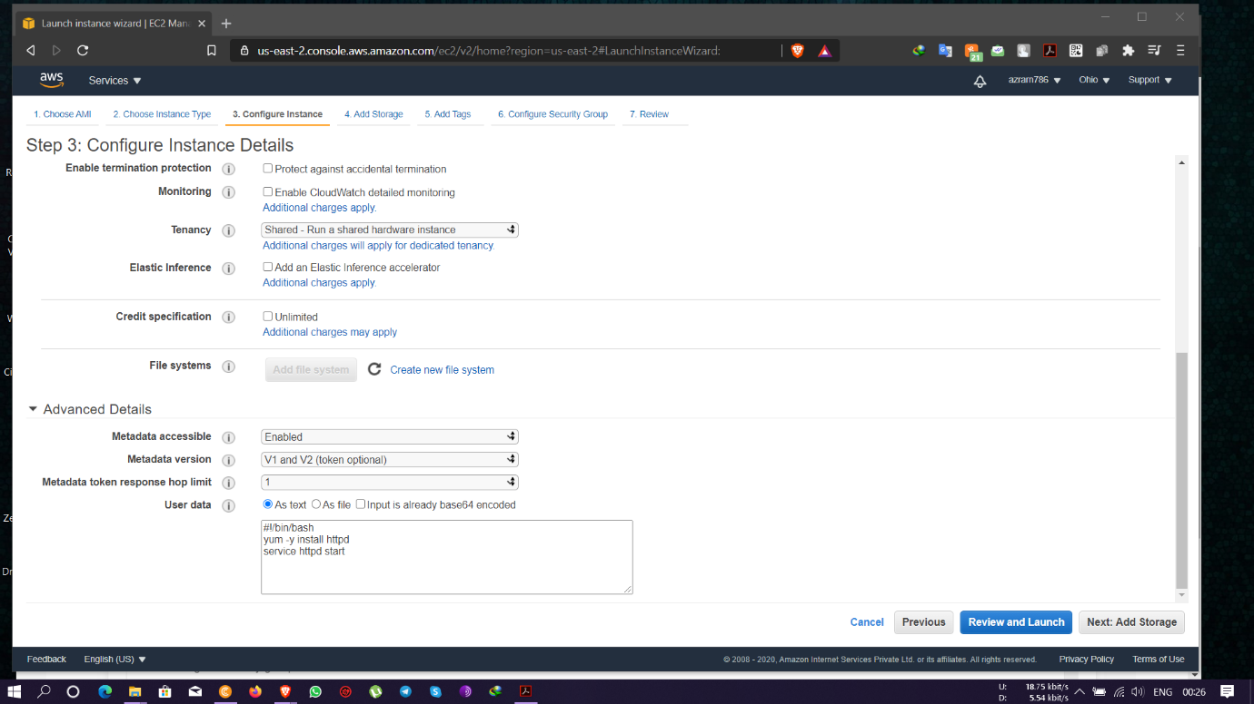

Instance Public IP- 3.15.26.206

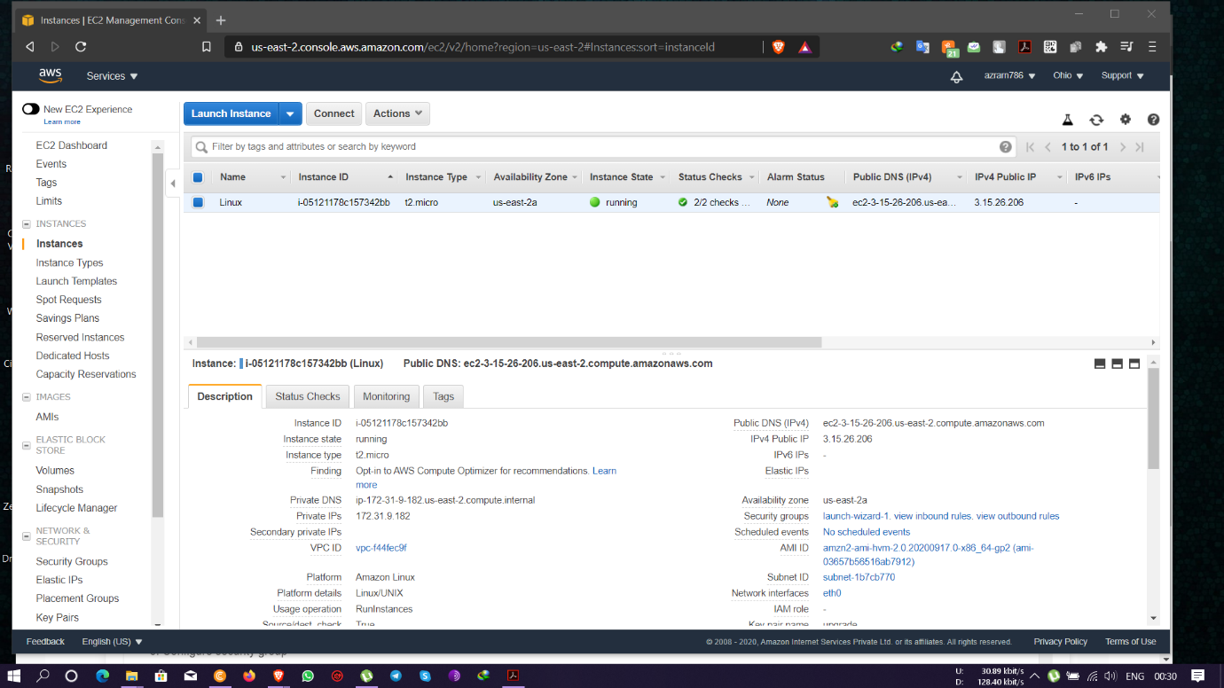

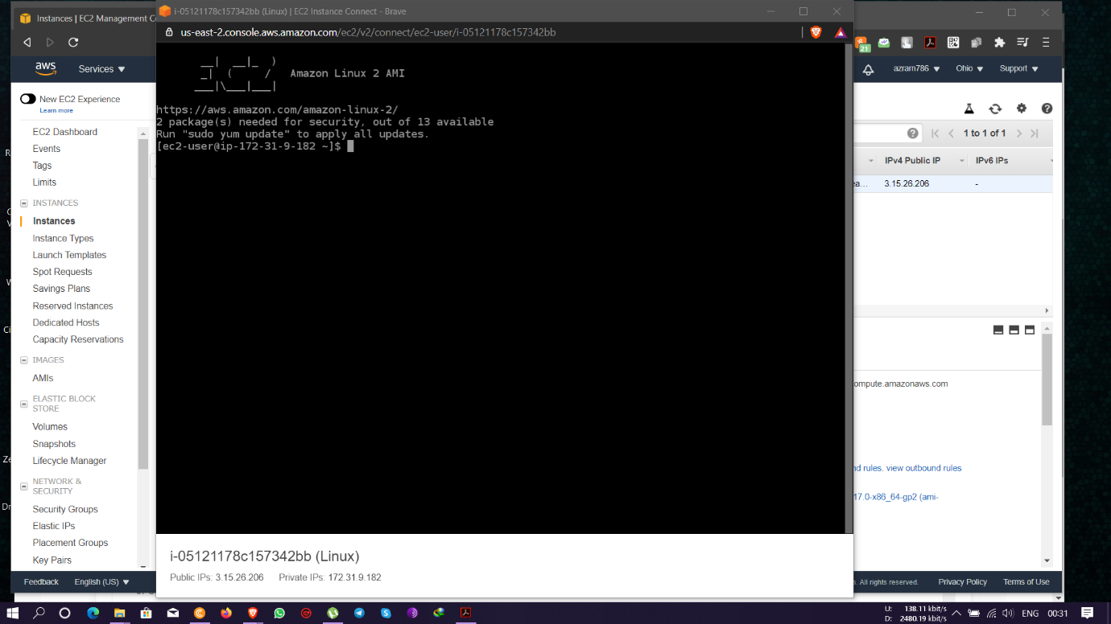

Test page Apache service running

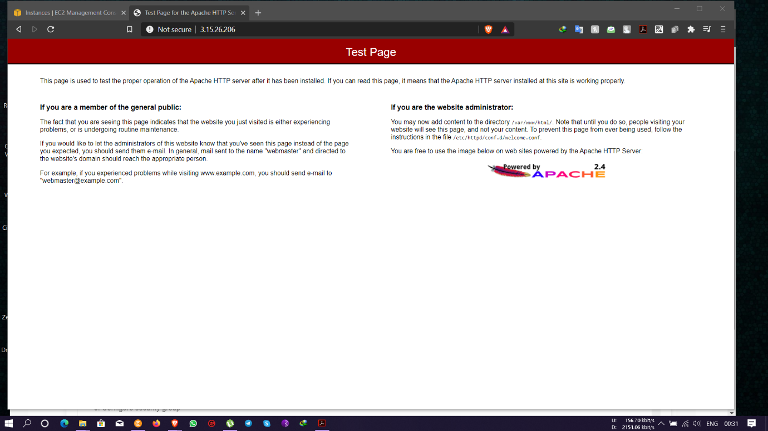

Task 2: Checking bucket list and creating a new bucket from EC2 using IAM Roles

* Creating IAM role with **AmazonS3FullAccess** permission policies

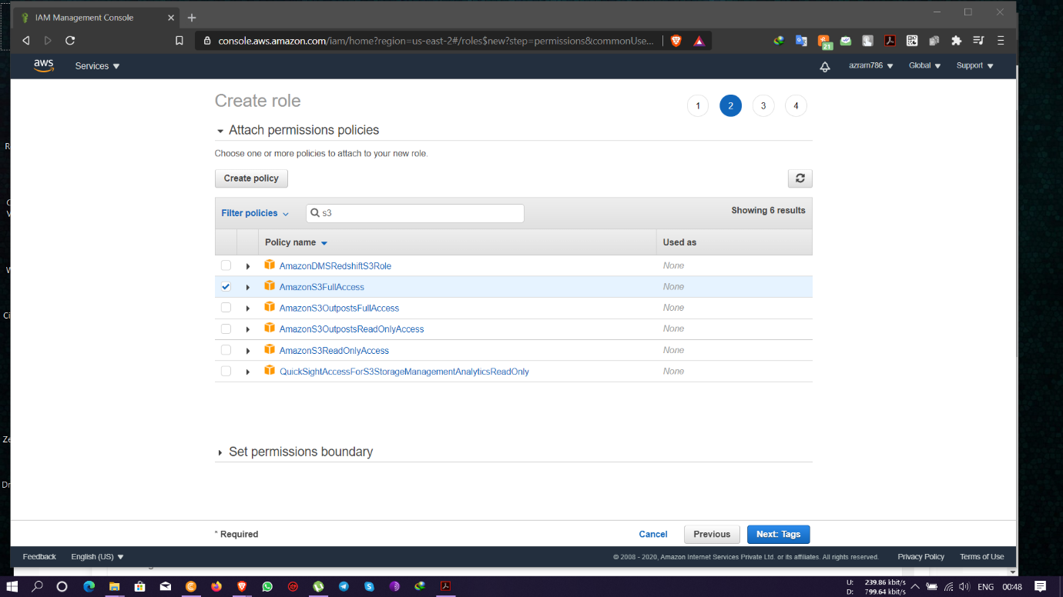

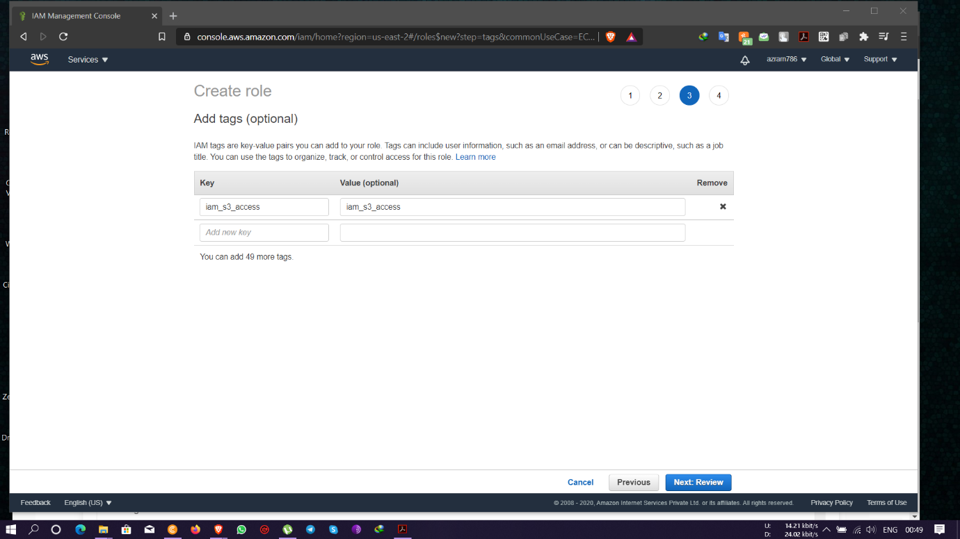

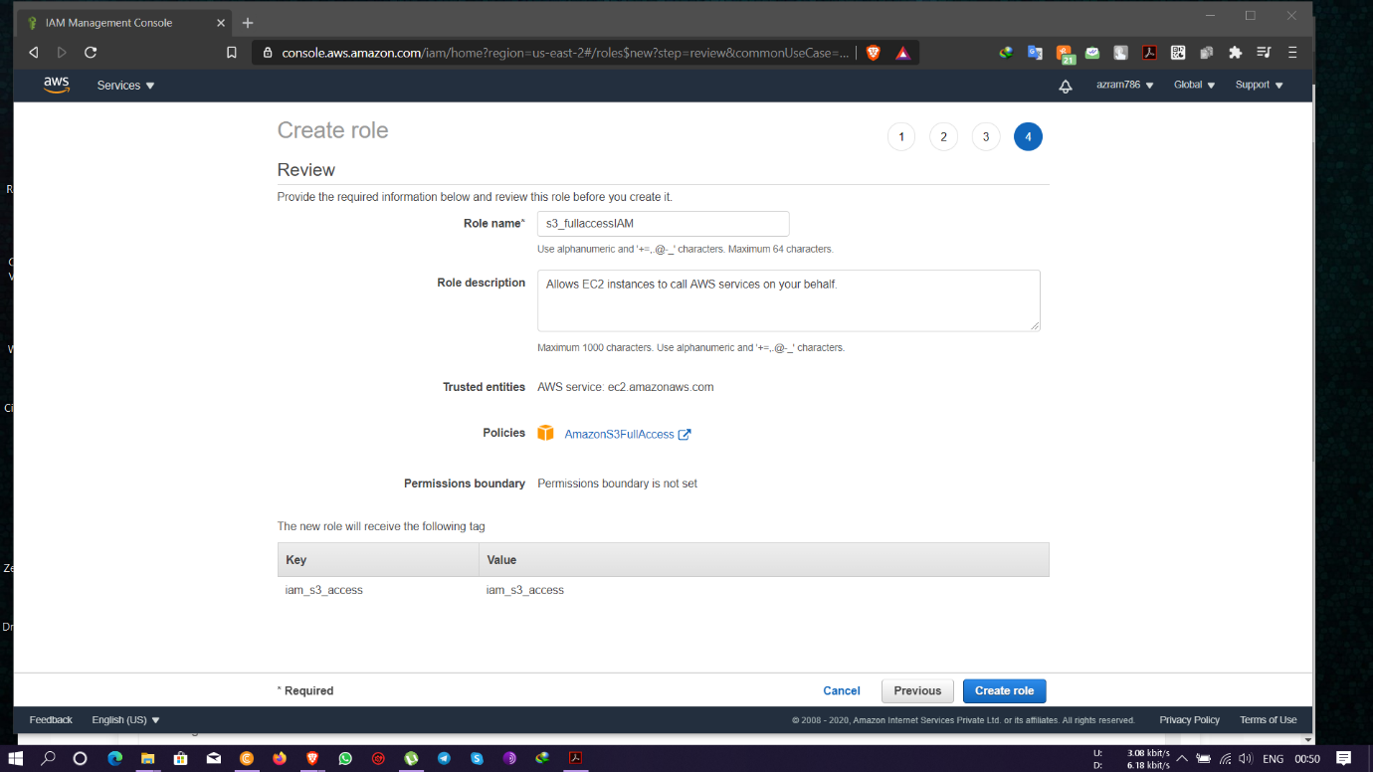

* Creating instance with IAM roles of S3 access

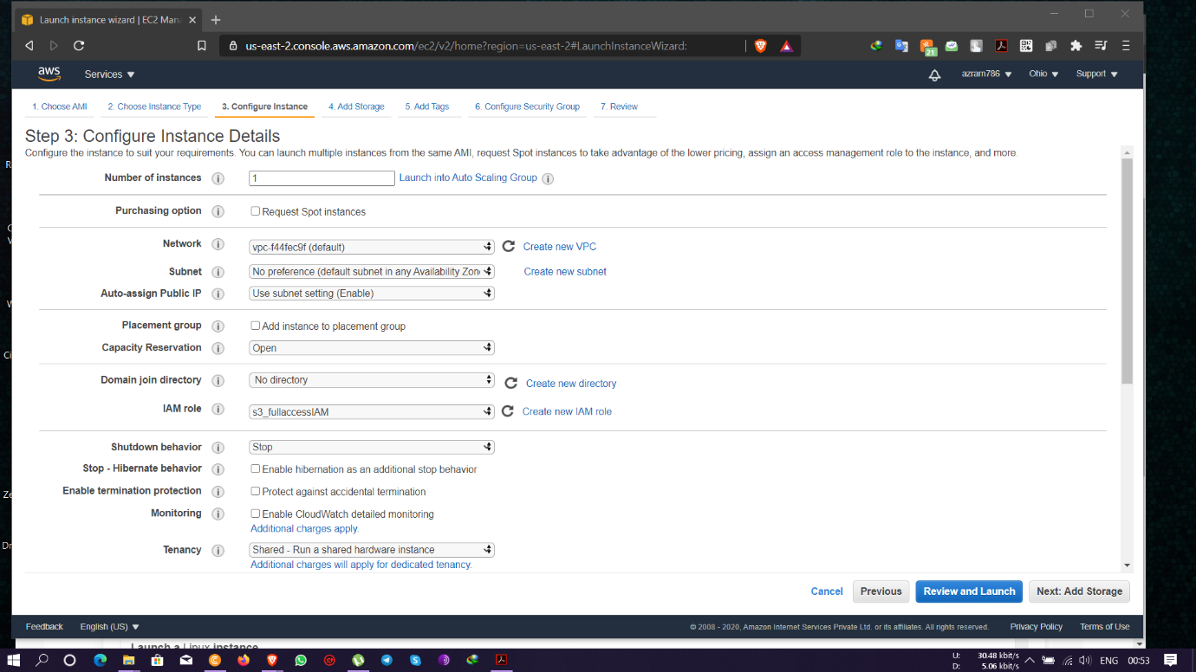

* Instance Public IP- 52.15.227.169

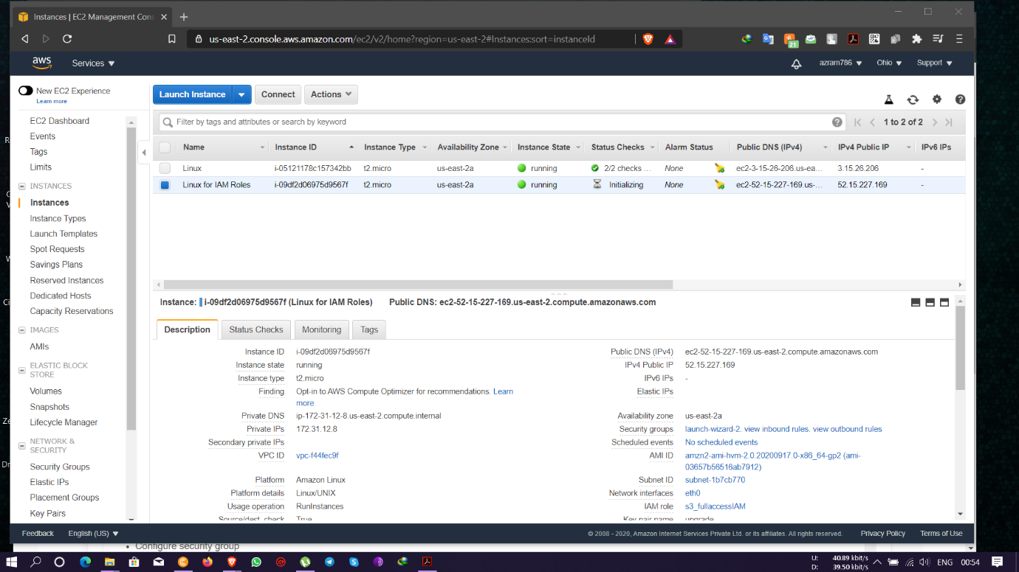

Commands executed to list and create S3 bucket-

sudo su

aws s3 ls

aws s3 mb s3://demolets567

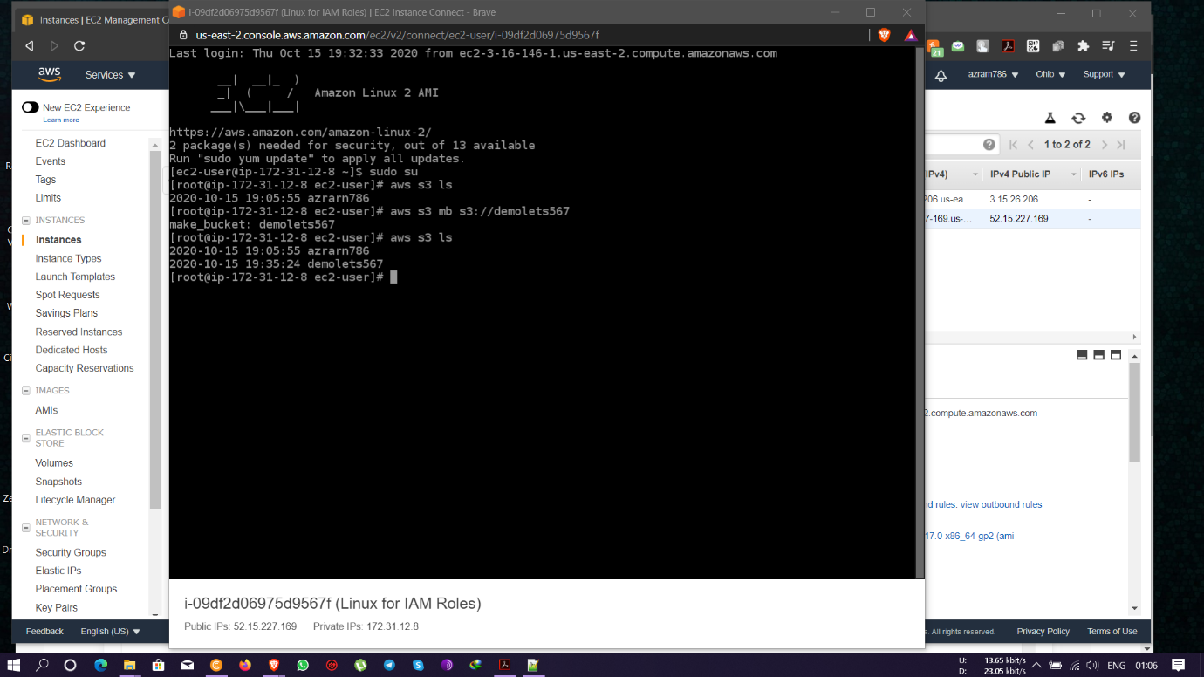

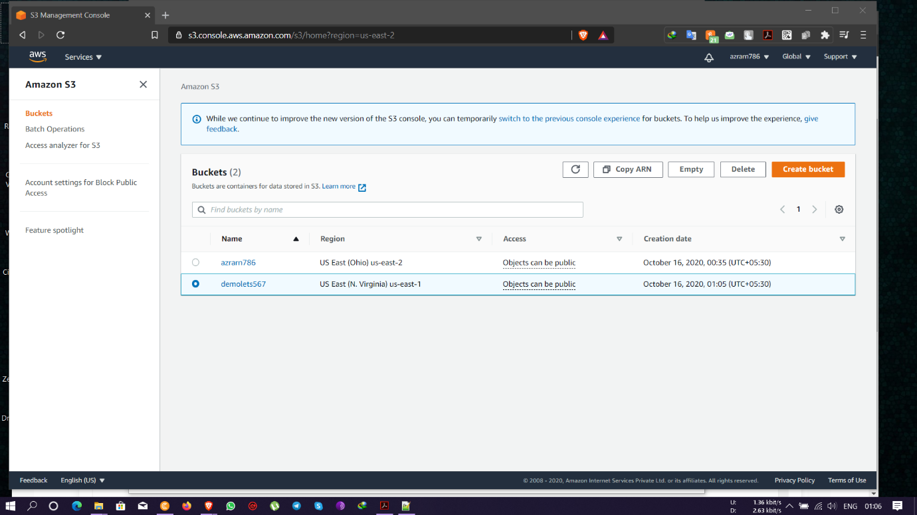

Task 3: Hosting a webpage using the bootstrap script on ec2.

* Uploading index.html file in AWS S3 bucket

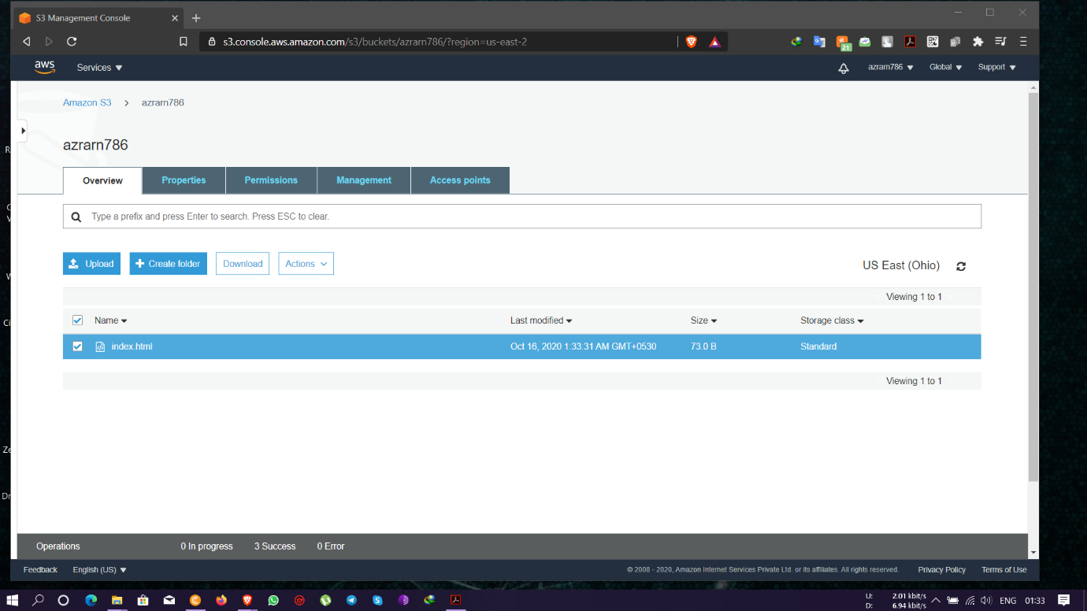

Creating Instance with the bootstrap script- #!/bin/bash

yum install httpd -y

aws s3 cp s3://azrarn786/index.html /var/www/html

service httpd start

chkconfig httpd on

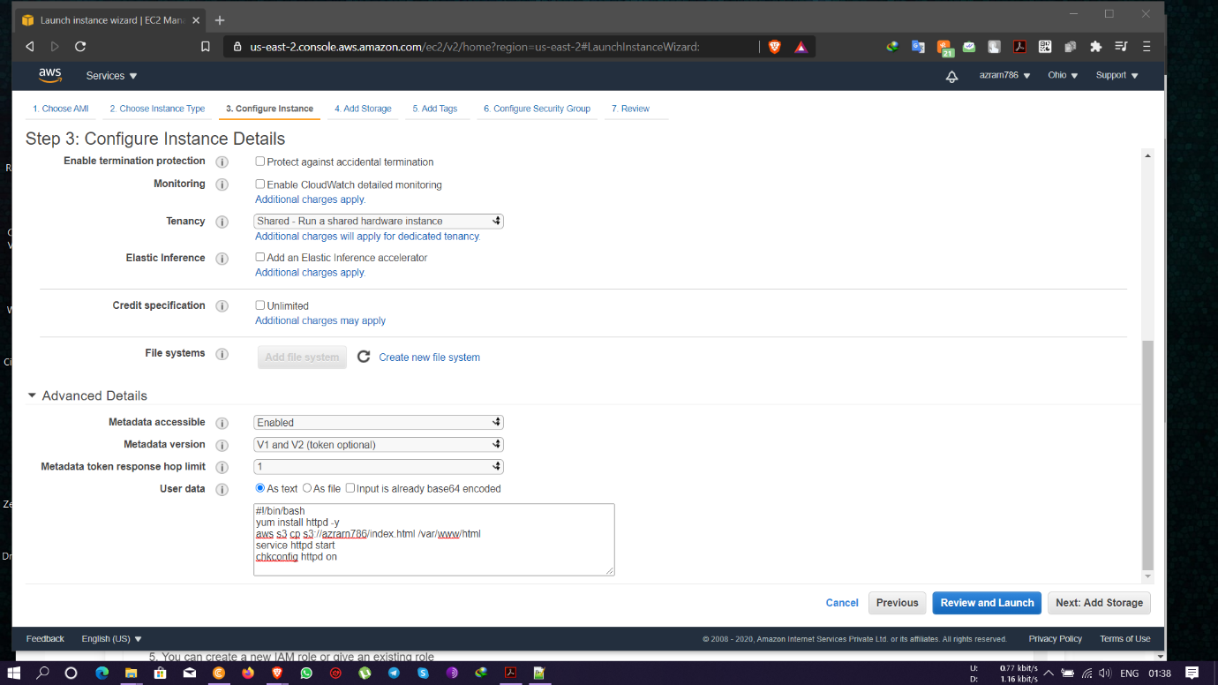

Instance Public IP- 18.188.198.223

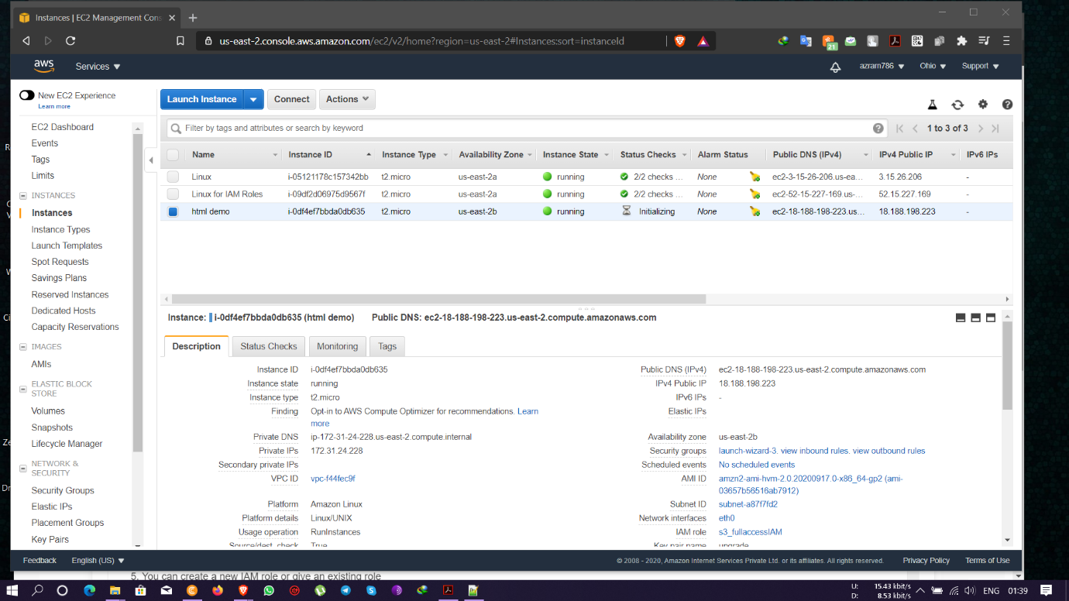

HTML test page live in the Public IP- 18.188.198.223

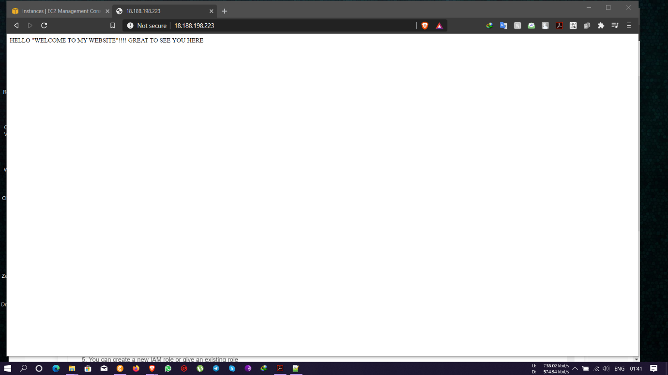

User data edit option available from the action option of the instance which can be done after stopping the instance

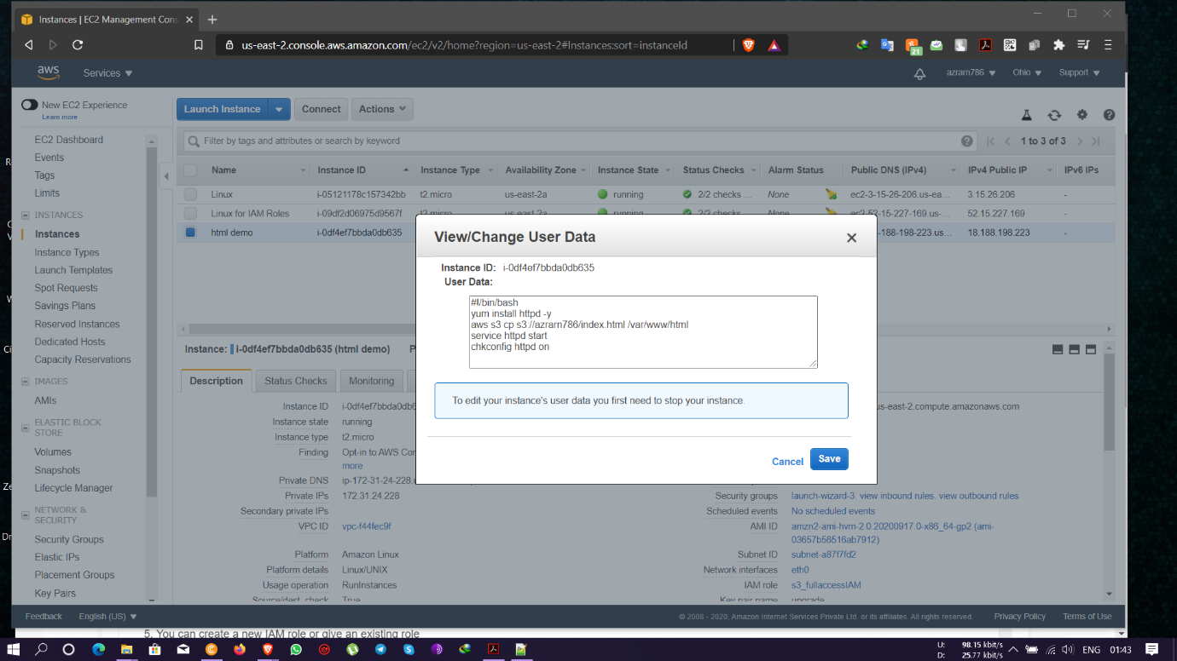

**PROJECT 2:**

**Creating an EC2 instance in custom VPC**

Task1: Create a VPC

* VPC created with Private IP- 172.19.0.0/16

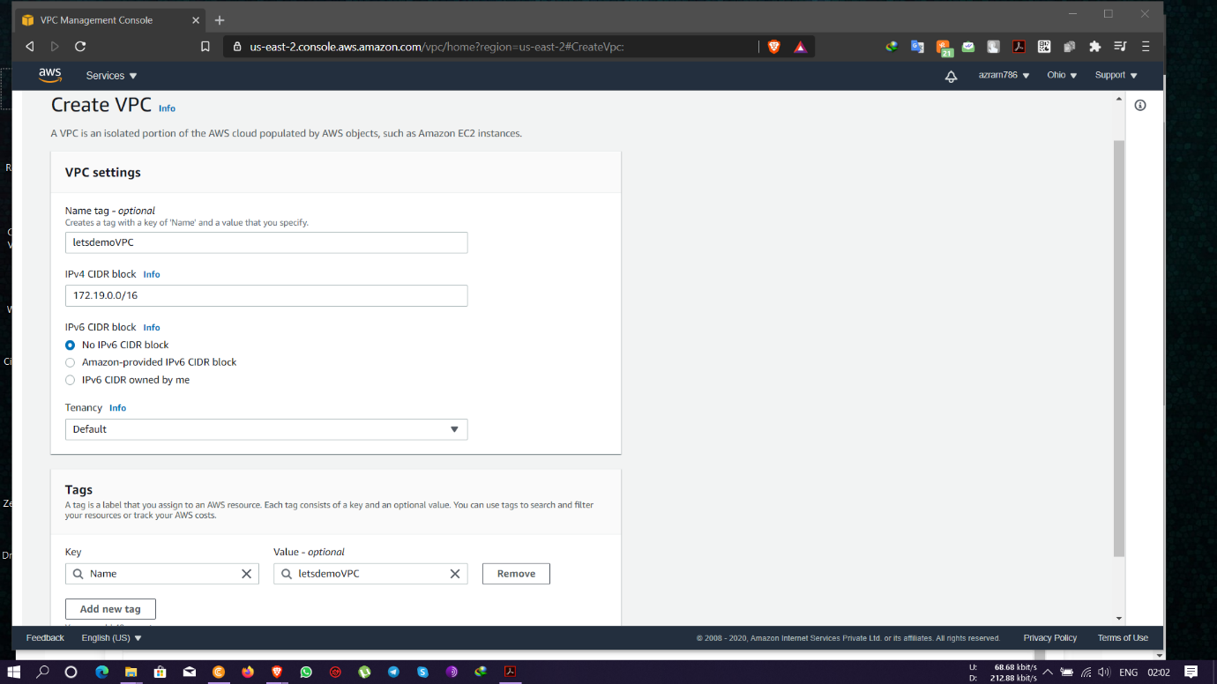

Task 2: Create an Internet gateway

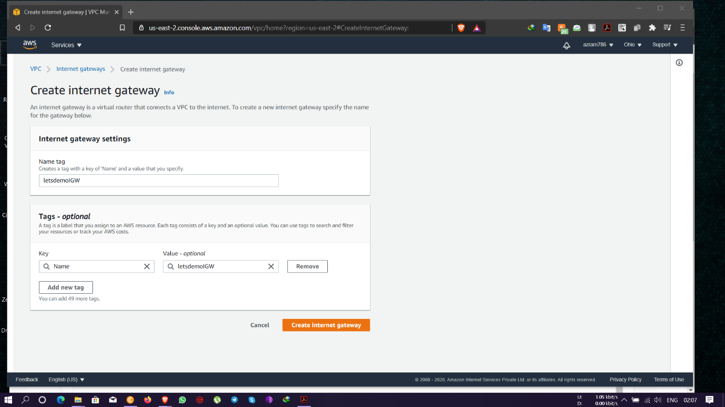

* Attaching IGW with a VPC

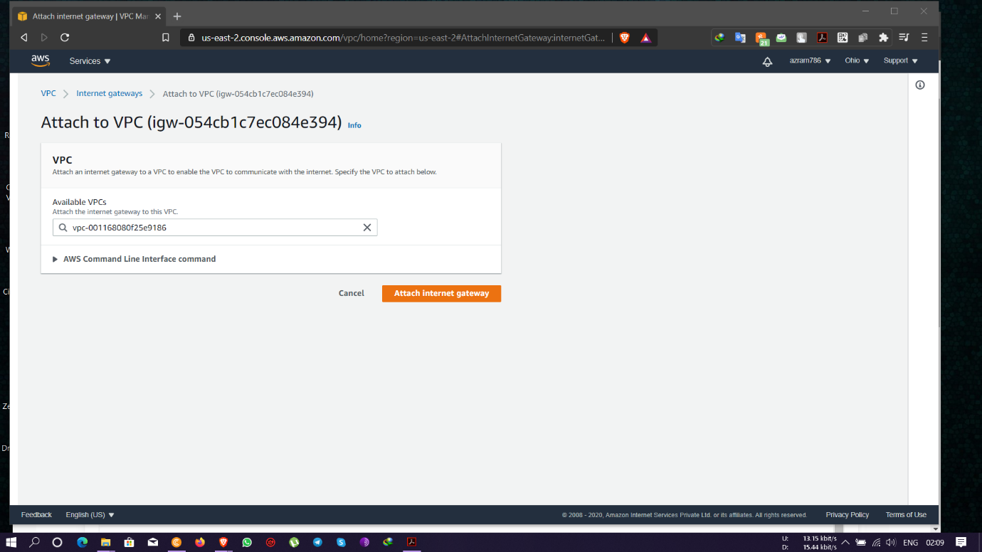

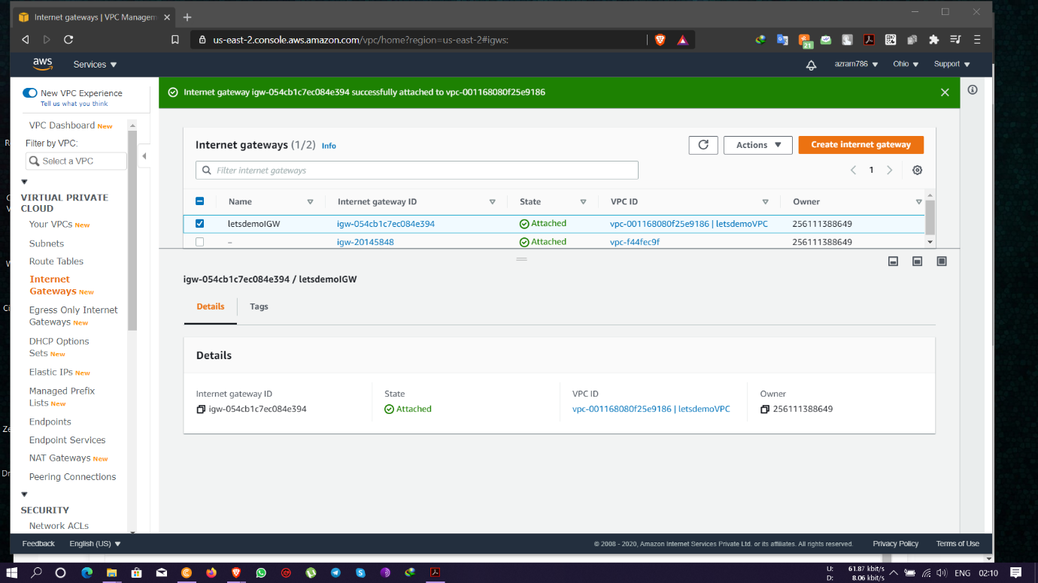

Task3: Create a route table

* Routing table created connecting it to the VPC

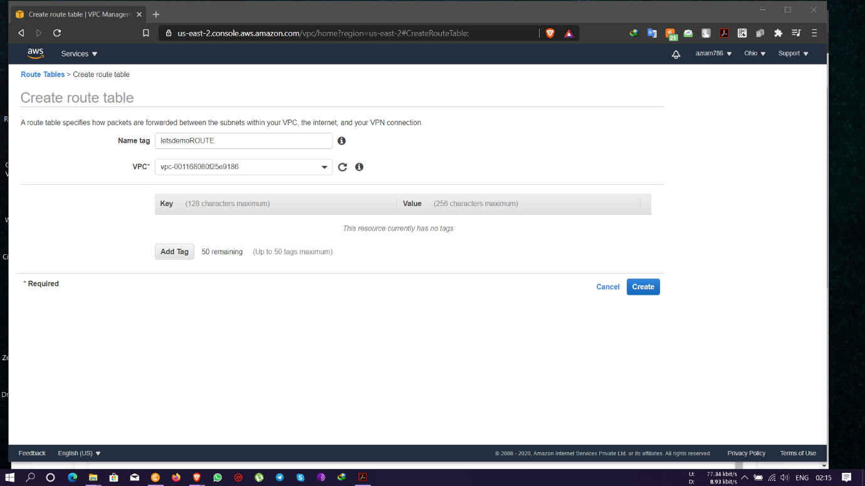

* Route table set to default route along with the VPC and IGW

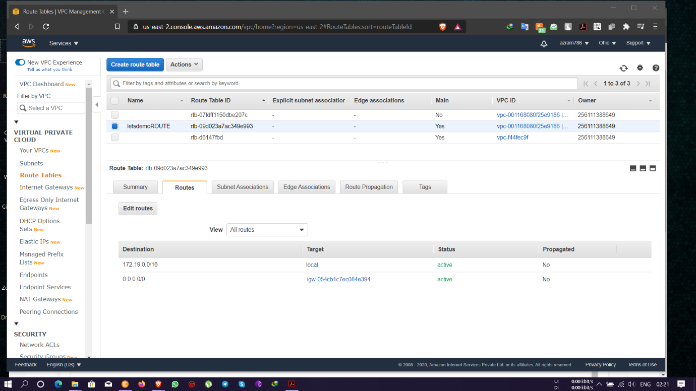

Task4: Create a subnet

* New Subnet created by connecting it to the VPC and providing a Private IP of- 172.19.0.0/24 and enabling auto assign public IP address.

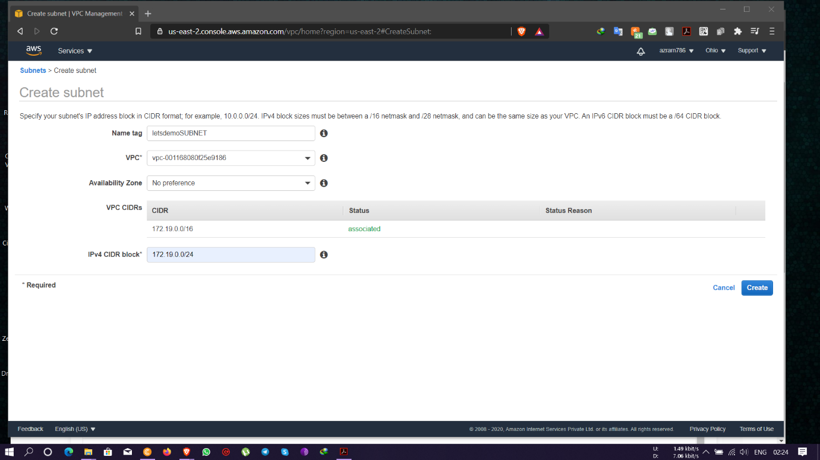

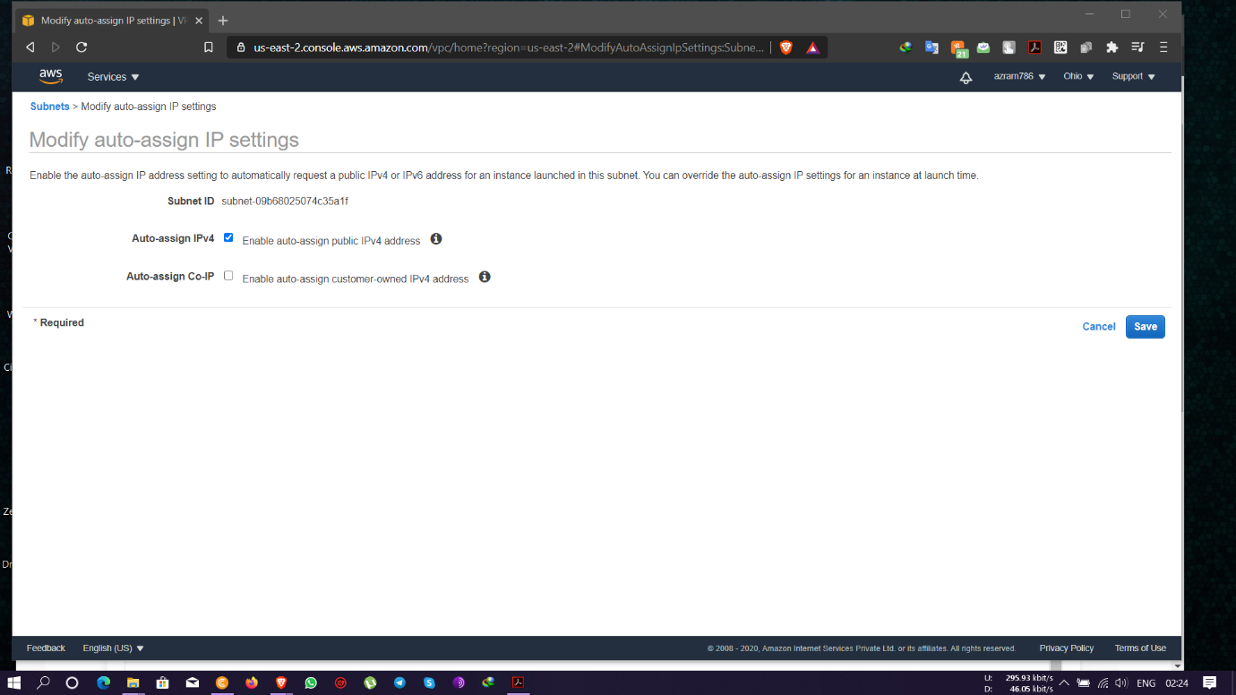

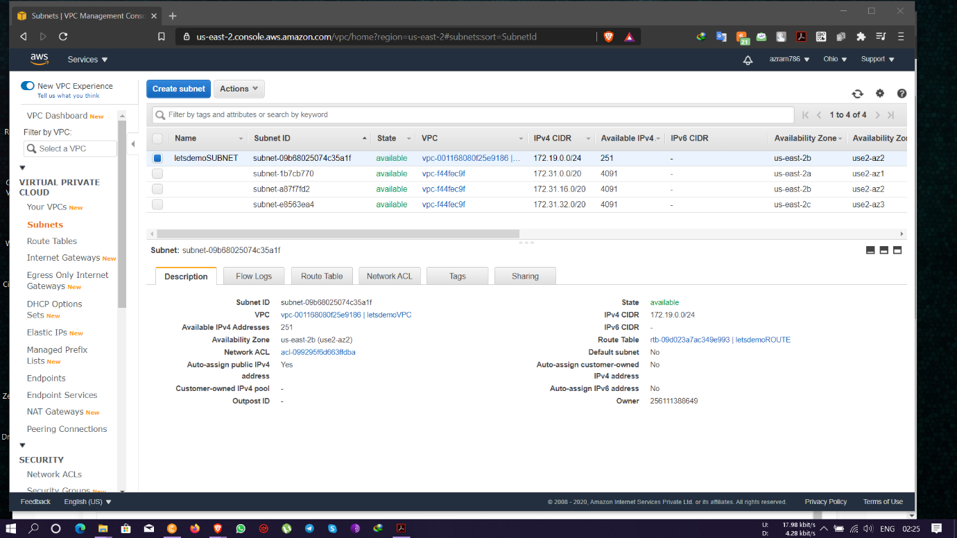

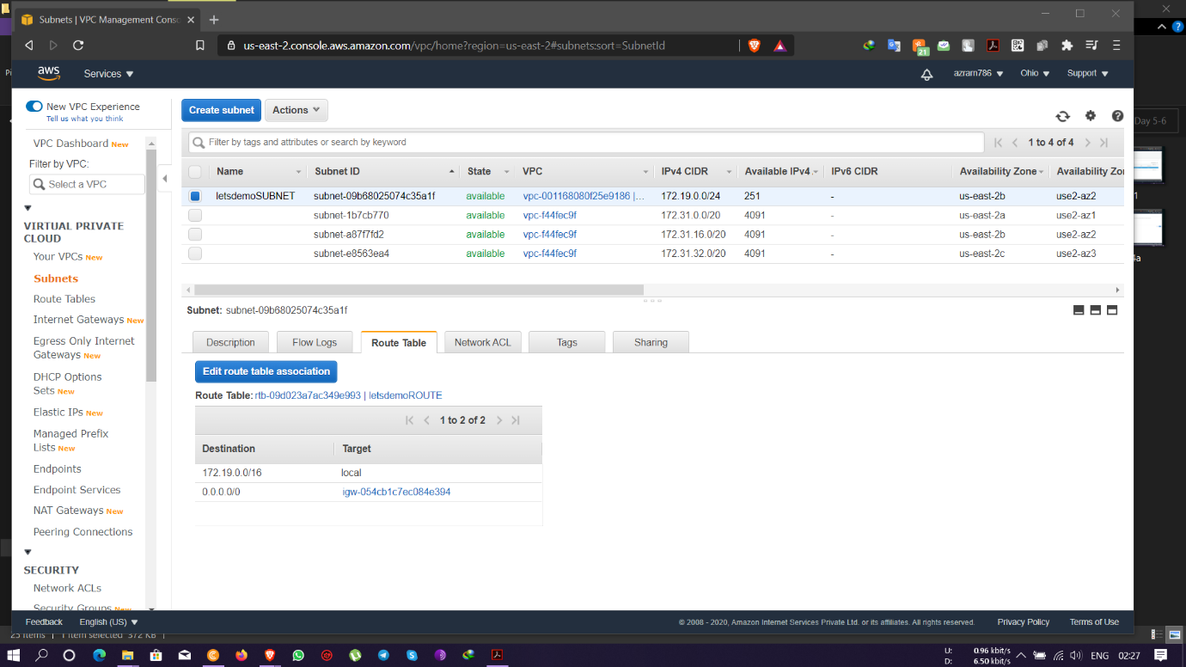

Task5: Create an EC2 in custom VPC

* Instance in custom VPC and its subnet and auto assigning Public IP

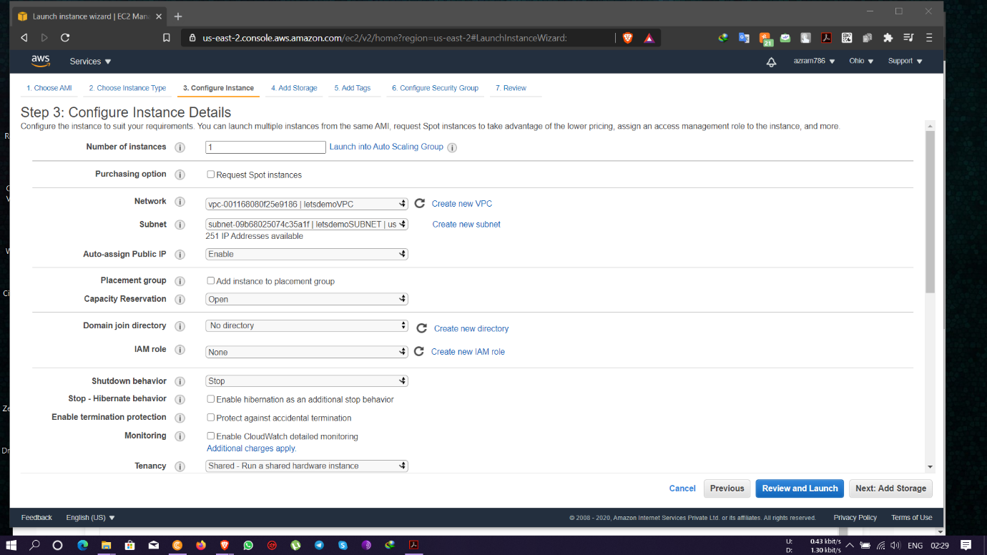

Instance running on Public IP- 3.128.247.175 and Private IP- 172.19.0.70

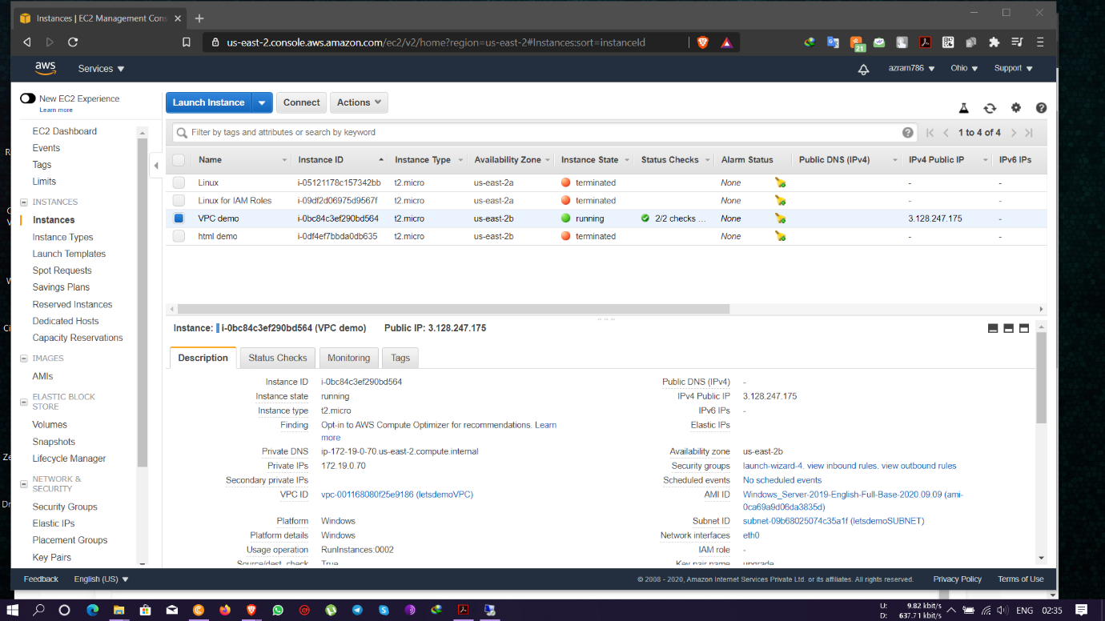

Task 6: Check ipconfig in VM command prompt.

In CMD with the command- **ipconfig** we get to see the following IP’s-

IPv4 address- 172.19.0.70

Subnet mask- 255.255.255.0

Default gateway- 172.19.0.1

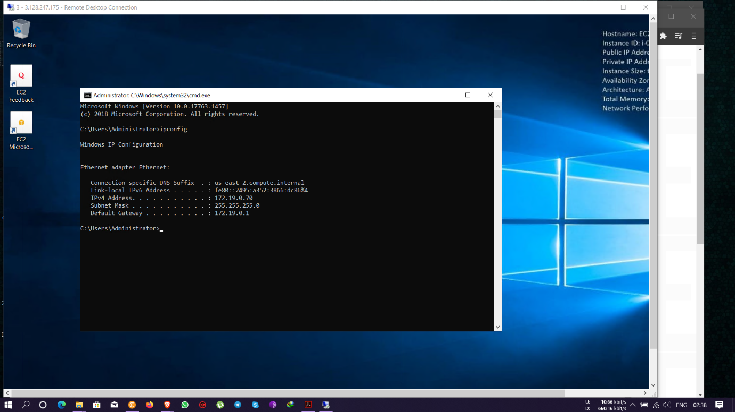

**Exercise of IAM Roles-**

Edit IAM roles in running state – yes, it is possible.

Edit IAM roles in off state – yes, we can edit.

Edit IAM roles after created – yes, it is possible after creating an IAM role.

We can detach an **IAM role** from a **running** or **stopped** instance.

To attach an **IAM role** to an instance that has no **role**, the instance **can** either be in **stopped** or **running state.**